# Uninstall old version

## Go to Control Panel and Uninstall Cisco AnyConnect

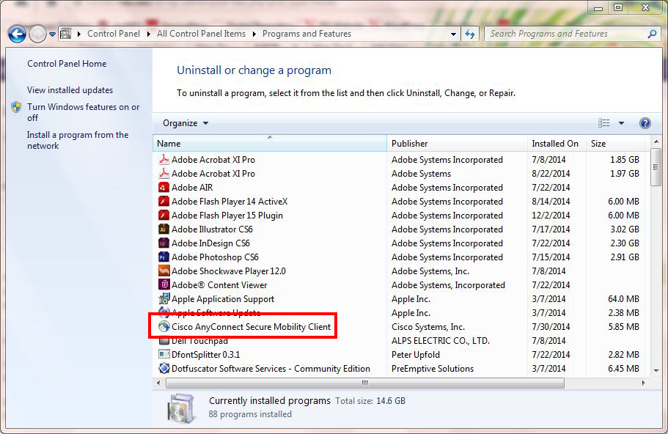

# Install AnyConnect web deployment new version on ASA

## Login Cisco website

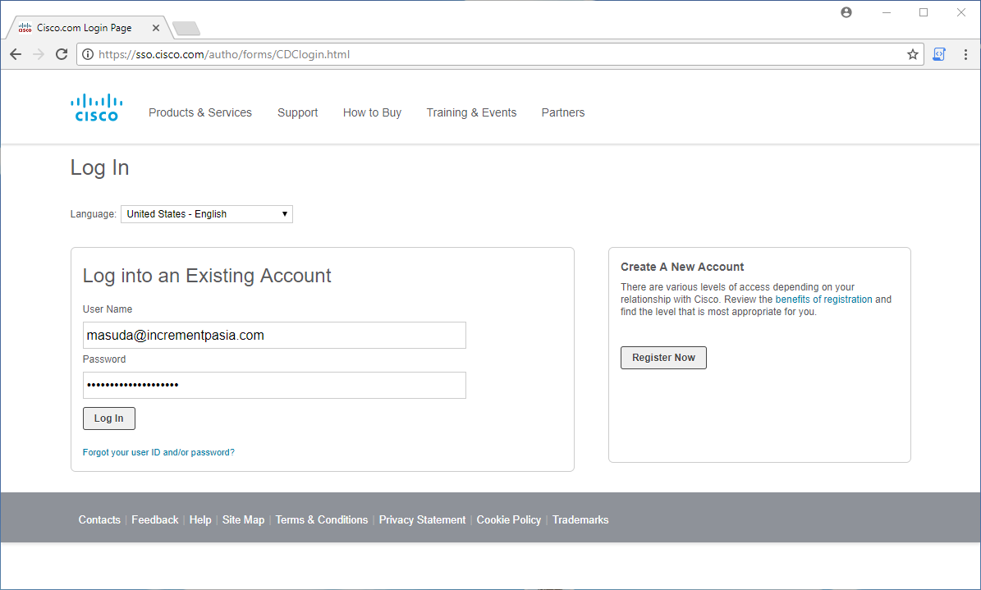

## Download Anyconnect web deployment new version

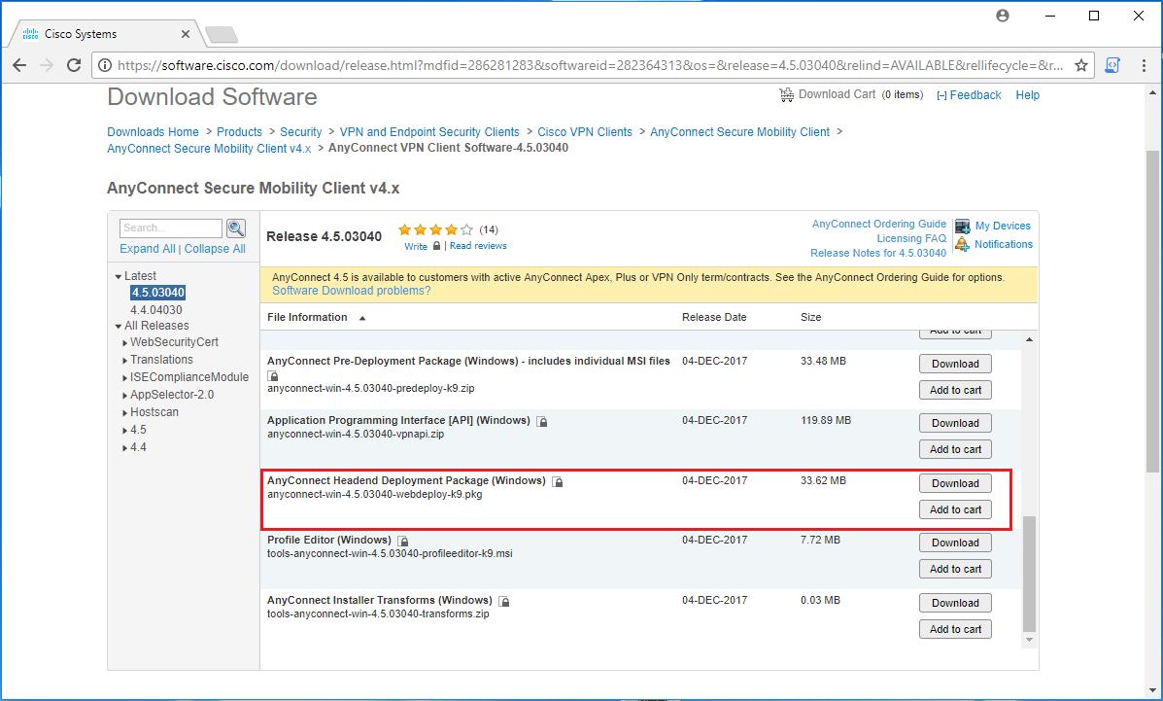

## Access ADSM via DC server

## Go to Anyconnect configure page

## Upload web deployment package to ASA

## Do ???

# Client download & install

## Do as manual say